Errata

At Dearborn™ Real Estate Education, we are proud of our reputation for providing the most complete, current, and accurate information in all our products. We are committed to ensuring the kind of quality you rely on. Please note the following changes, which will be reflected in the next printing of Modern Real Estate Practice in North Carolina Ninth Edition.

To use this document, you will need to know which revision of the book you have. The revision is indicated on the copyright page, which is on the second page of the book.

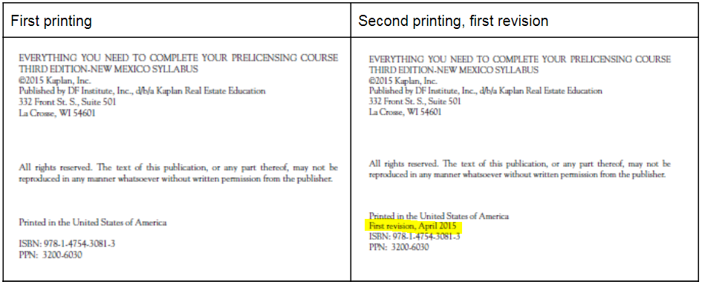

Page/Location | Was | Change to
NOTE: 2017 Forms and are available (These will not be updated in the next ninth edition printing)
22 | ■ surface rights,  ■ surface rights,  ■ subsurface gas and oil rights, and  ■ air rights. | ■ surface rights,  ■ subsurface gas and oil rights, and  ■ air rights.
67, 12 | The following North Carolina brokers can file a lien to secure payment of brokerage fees EXCEPT  a. a listing agent for a $10 million mansion.  b. a tenant’s representative for the lease of a manufacturing plant.  c. a listing agent for the sale of a shopping center.  d. a buyer’s agent for the purchase of an office building. | Which of the following North Carolina brokers can file a lien to secure payment of brokerage fees  a. A listing agent for a $10 million mansion  b. A tenant’s representative for the lease of a manufacturing plant  c. A listing agent for the sale of a shopping center  d. A buyer’s agent for the purchase of an office building
316 | If the optionor wishes to go forward with the purchase, the optionor must exercise his or her right to buy, typically in writing. Once an option has expired, the optionor no longer has the right to buy under the terms of the agreement. | If the optionee wishes to go forward with the purchase, the optionee must exercise his or her right to buy, typically in writing. Once an option has expired, the optionee no longer has the right to buy under the terms of the agreement.
380, question 16 | a. Employee wages  b. Utilities  c. Building repairs  d. Basic operating costs | a. Employee wages  b. Property taxes  c. Building repairs  d. Basic operating costs
405-406, Figure 14.5 | Short Sale Addendum To Exclusive Right To Sell Listing Agreement | Short Sale Addendum  Source: Reprinted with permission of the North Carolina Association of REALTORS®.  (See below for the Short Sale Addendum form)  (NOTE: This will not be updated in the next ninth edition printing)
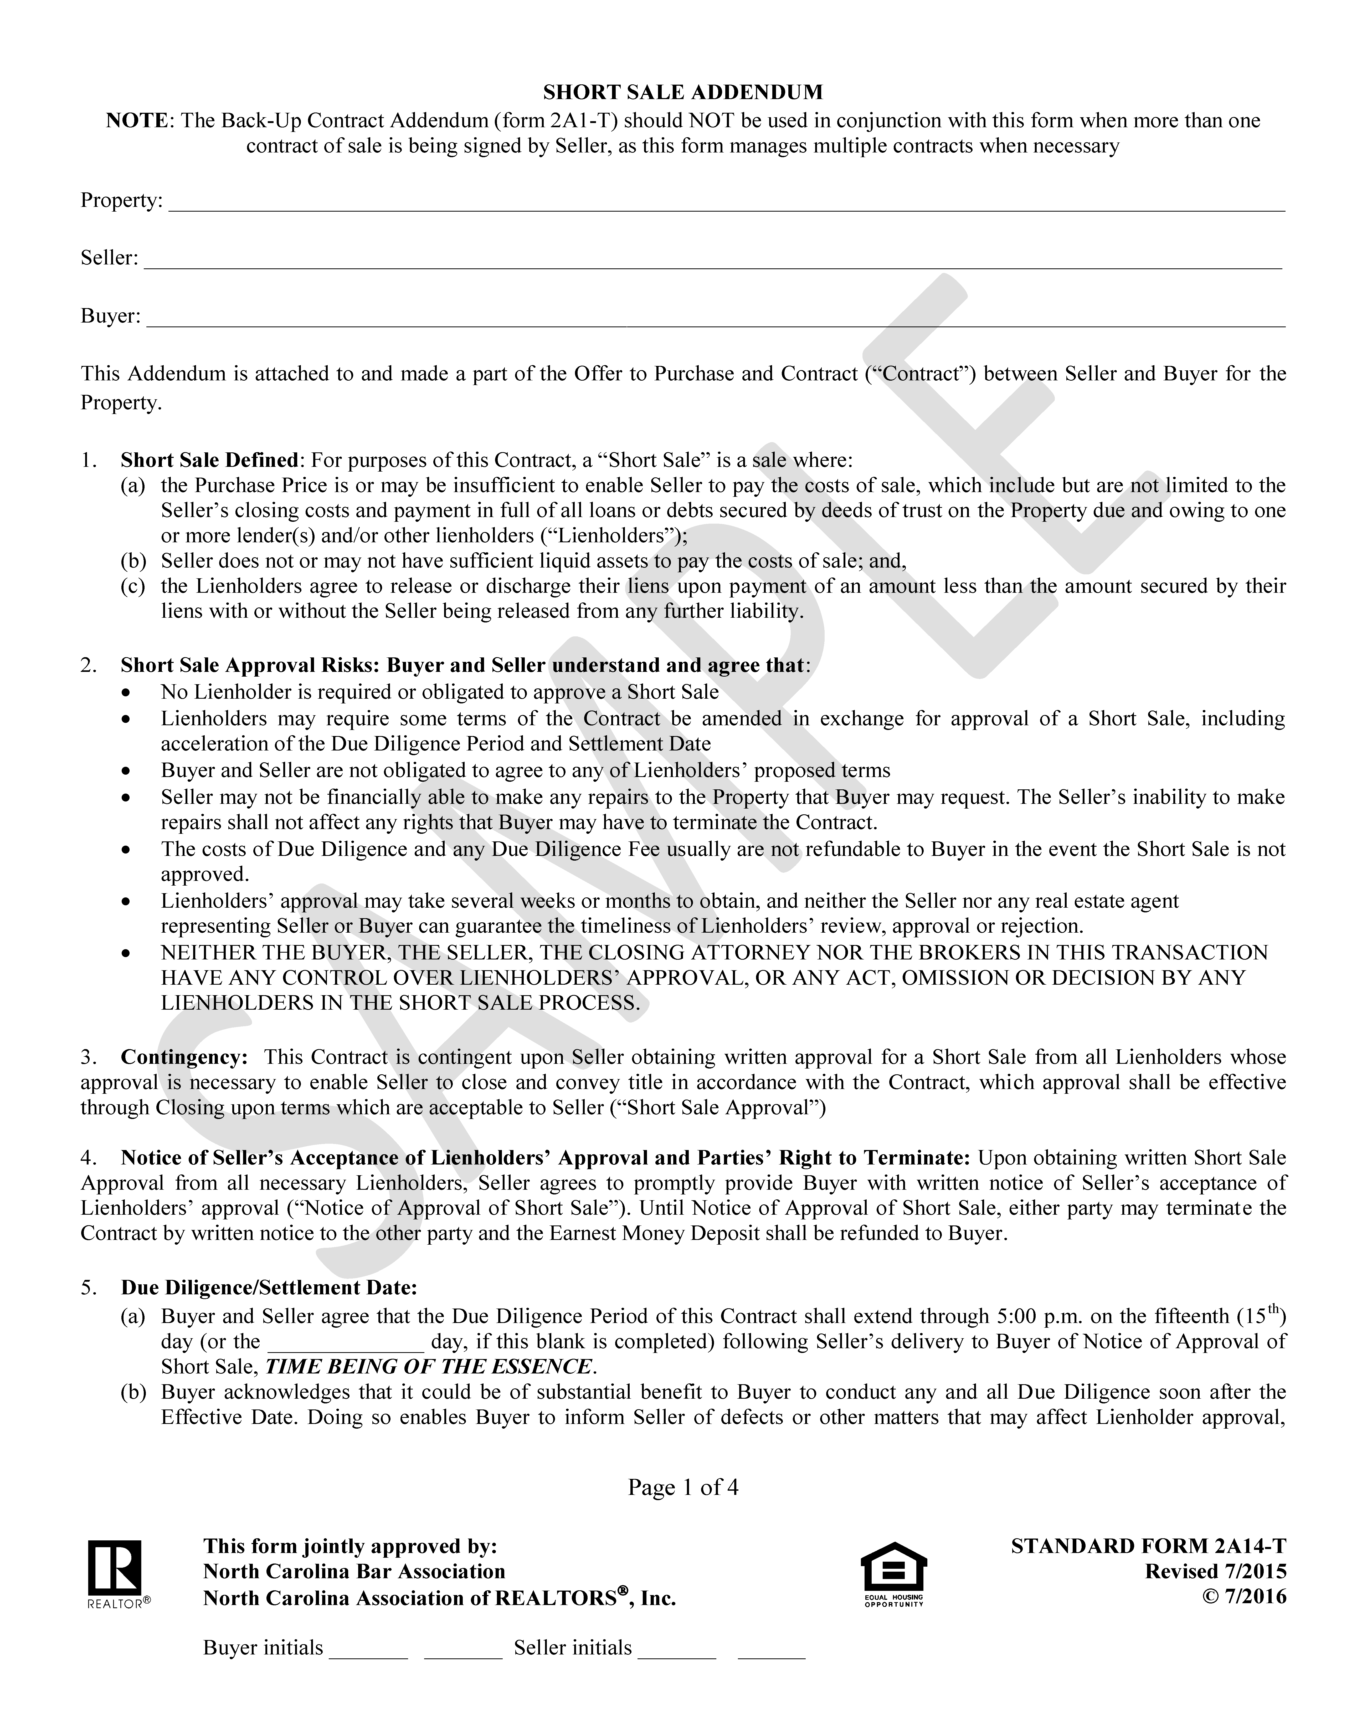
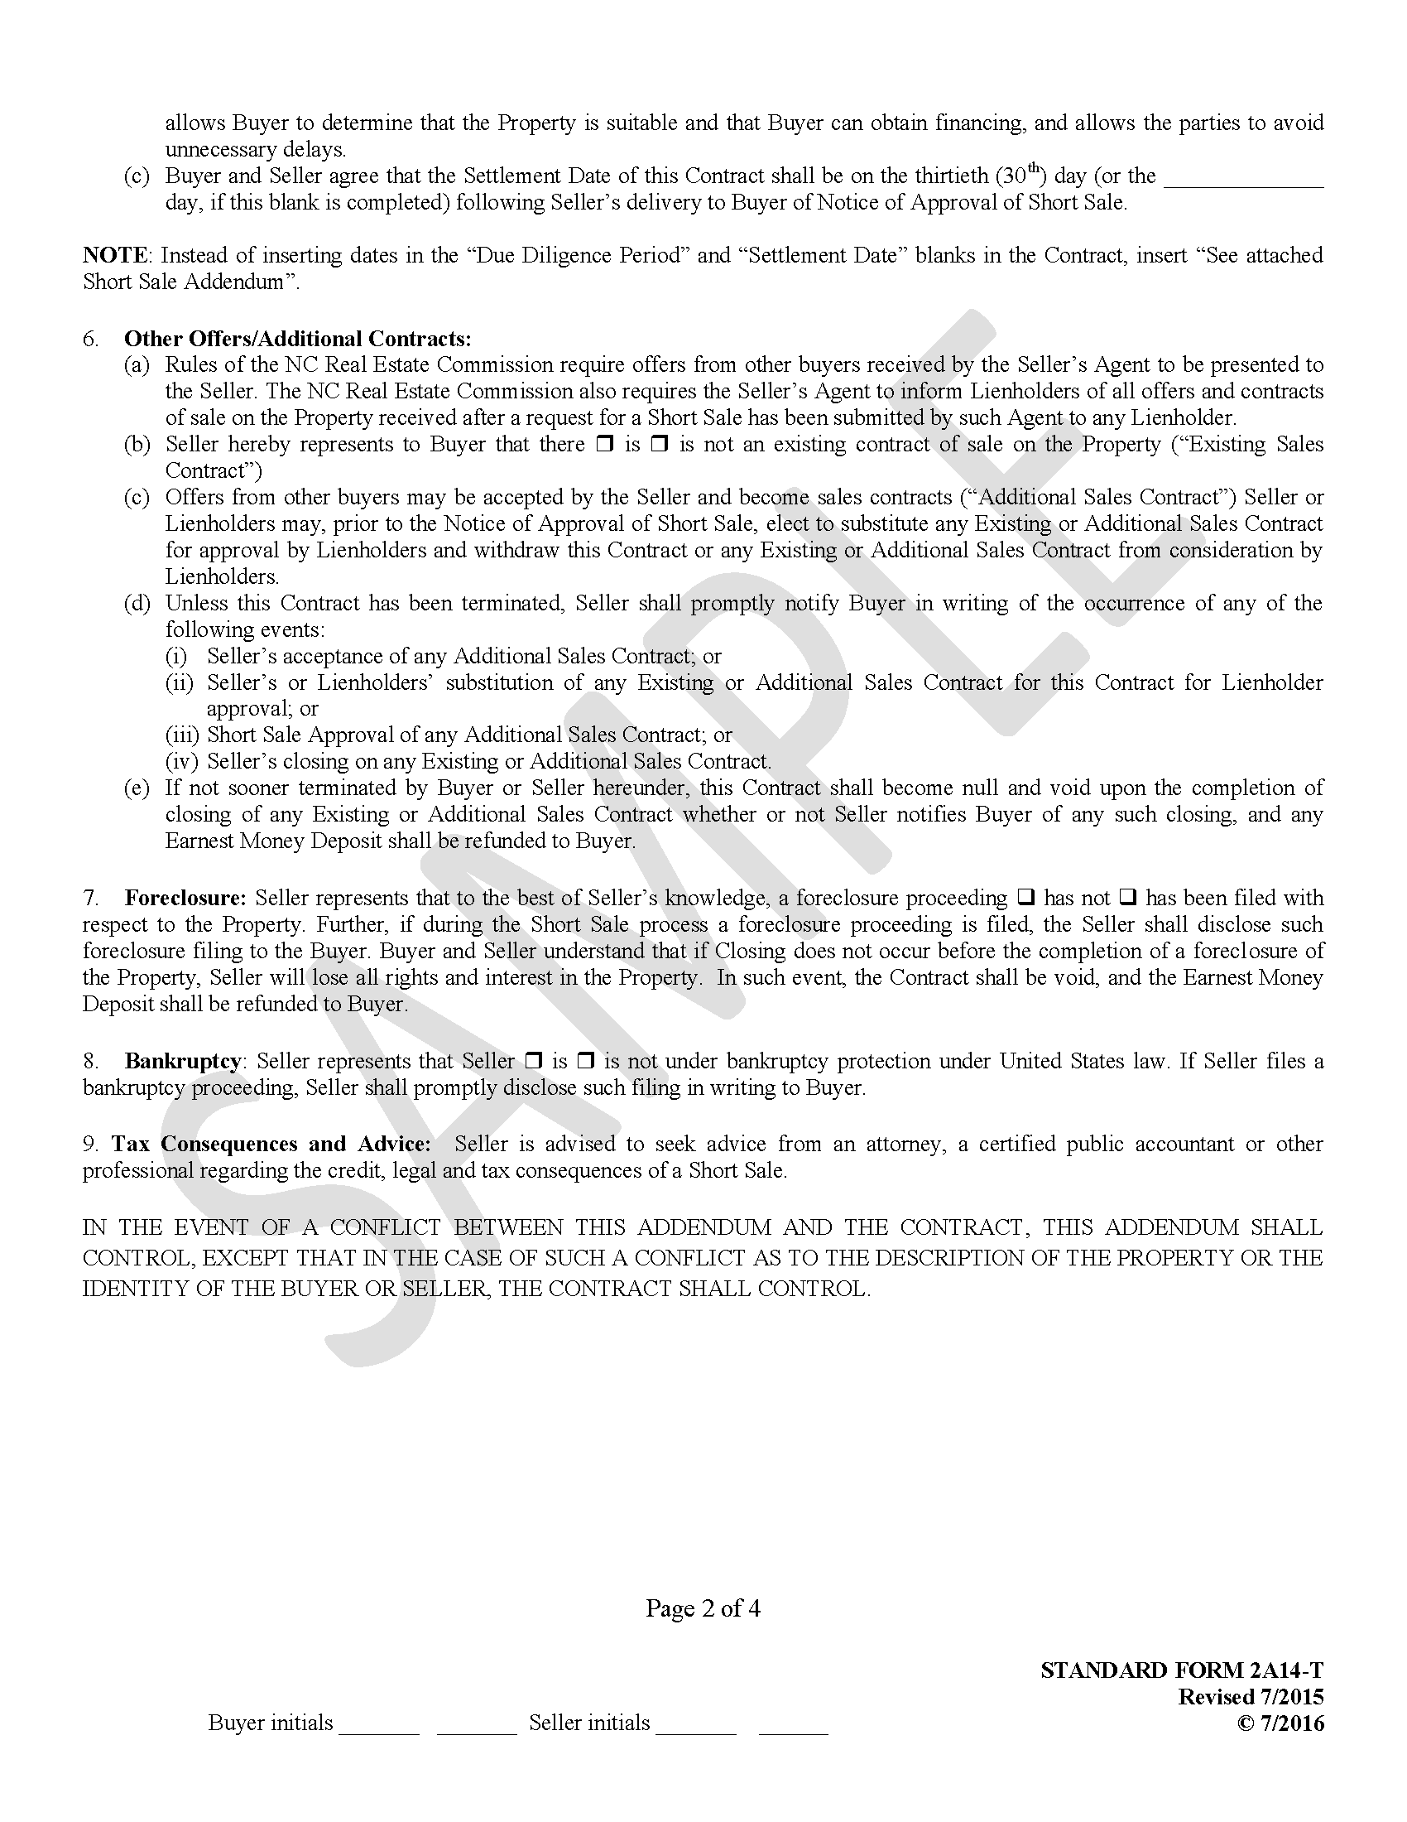
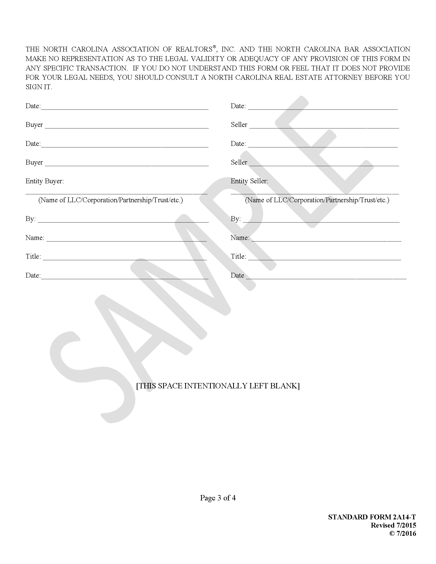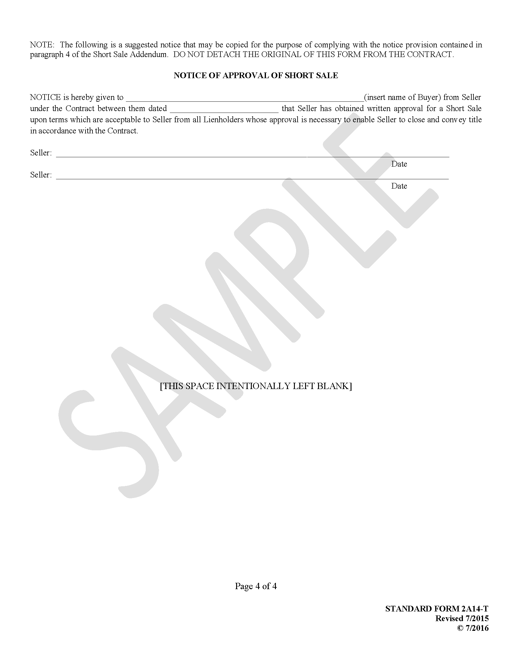
494 | Weighted Averages: Comparable #1 is weighted 35%; Comparable #2 is 25%, and Comparable #3 is 40%. What is the estimated value of the subject? | Weighted Averages: Comparable #1 is weighted 25%; Comparable #2 is 40%, and Comparable #3 is 35%. What is the estimated value of the subject?
494, Table, Comp #1, Indicated value | $35,652 | $35,625
495, Table, Comp #1 | -$10,000  Adj. Market Values $190,000 | +$10,000  Adj. Market Values $210,000
495, Table, Comp #2 | -$10,000  Adj. Market Values $200,000 | +$10,000  Adj. Market Values $210,000
509 | The Bowers will only owe capital gains tax on a total gain of over $700,000. | The Bowers will only owe capital gains tax on a total gain of over $500,000.
514, 12 | In question 9, if the property were an investment property, how much of the gain would be subject to income tax? | In question 11, if the property were an investment property, how much of the gain would be subject to income tax?
808, Unit 3, 1. | c | b
808, Unit 3, 12 | a | c
809, Unit 5, 19 | c | d
809, Unit 5, 20 | e | d
810, Unit 7, 25 | c | d
812, Unit 13, 9 | c | b
814, Unit 17, 29 | $1,000 per month × 125 (GRM) = $125,000 (value) | $1,000 per month × 125 (GRM) × 2 units= $250,000 (value)
814, Unit 17, 33 | d | c
820, Appendix A, 1 | a | c
615-637, Appendix A | License Law and Rule Comments | License Law and Rule Comments  *See www.ncrec.gov/Resources/LicenseLaw  (NOTE: This will not be updated in the next ninth edition printing)
638-677, Appendix A | Real Estate Licensing in North Carolina  Published by the North Carolina Real Estate Commission  May 2016 | Real Estate Licensing in North Carolina  Published by the North Carolina Real Estate Commission  July 2017  *See www.ncrec.gov/Brochures/general.pdf  (NOTE: This will not be updated in the next ninth edition printing)

First Revision
Page/Location | Was | Change to
419, Mortgage Loan Repayment Plans—Balloon Payment Loan | A loan for $80,000 at 10% interest may be computed on a 30-year amortization schedule but paid over a 20-year term, with a final balloon payment due at the end of the 20th year. | A loan for $80,000 at 11.5% interest may be computed on a 30-year amortization schedule but paid over a 20-year term, with a final balloon payment due at the end of the 20th year.
426, The Federal Reserve System |  | (Add to the end of the first paragraph)  Qualified state-chartered banks may also join the Fed.
427, Open Market Condition | The Fed regulates the flow of money and interest rates in the marketplace through its member banks by controlling their reserve requirements and discount rates. | The Fed regulates the flow of money and interest rates in the marketplace through its member banks (and other depository institutions) by controlling their reserve requirements and discount rates.
537, question 17 | c. intentional neglect of a broker to show an family from a particular race property listings in all-white neighborhoods. | c. intentional neglect of a broker to show a family from a particular race property listings in all-white neighborhoods.

