**Errata**

At Dearborn™ Real Estate Education, we are proud of our reputation for providing the most complete, current, and accurate information in all our products. We are committed to ensuring the kind of quality you rely on. Please note the following changes, which will be reflected in the next printing of *Modern Real Estate Practice Study Guide, 20th Edition*

To use this document, you will need to know which revision of the book you have. The revision is indicated on the copyright page, which is on the second page of the book.

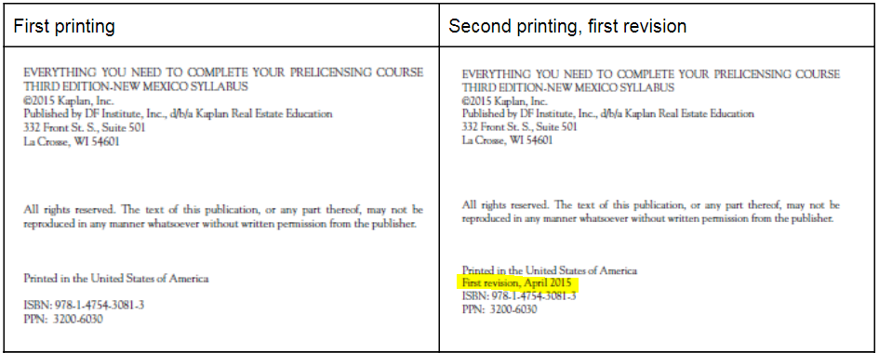

**FIRST PRINTING**

|  |  |  |
| --- | --- | --- |
| **Page/Location** | **Reads Now** | **Should Be** |
| 5 | apprecation | appreciation |
| 26/Matching A | 1. I  2. C  3. A  4. J  5. D  6. E  7. G  8. H  9. E  10. B | 1. J  2. D  3. A  4. B  5. E  6. F  7. H  8. I  9. G  10. C |
| 26/Matching B | 1. I  2. G  3. J  4. E  5. D  6. H  7. A  8. F  9. C  10. B | 1. J  2. H  3. B  4. F  5. E  6. I  7. A  8. G  9. D  10. C |
| 52/Matching B, item 4 | A deed that contains no covenants, warranties, or implications, and that provides the least amount of protection of any deed   |  | | --- | |  |  |  |  | | --- | --- | | |  | | --- | |  | | | A conveyance by deed from a trustee to anyone other than the trustor |
| 80/Activity,Image | Incorrect image | Correct Image: |
| 98/Matching, item I | Indemnification (hold harmless) wording | Indemnification (hold harmless) clause |
| 108/Listing Workshseet table, row 4, column 4 (kitchen floor cover) | vinyl | ceramic |
| 124/Matching A, item 1 | The borrower in a mortgage loan clause | The borrower in a mortgage loan |
| 125/Matching B, item G | lien theory | straight loan |
| 125/Matching B, item 10 | Idea that a mortgage is purely a lien on real property | Loan that requires payments of interest only, with the entire principal due at the end of the loan term |
| 125/Matching B, item 11 | Concept that the borrower actually gives legal title to the lender (or other party) and retains equitable title | Agency that certifies housing counselors to assist borrowers |
| 143/Item 25 | The real estate financing market is comprises | The real estate financing market comprises |
| 150/Item 5, choice C | The lender must provide a new Closing Disclosure and obtain a waiver from the buyer of the three-day waiting period so that closing can occur on schedule. | The lender must provide a new Closing Disclosure and obtain a waiver from the seller of the three-day waiting period so that closing can occur on schedule. |
| 202/Matching, item J | surety board | surety bond |
| 220/Fill-in-the-Blank, item 2 | Zoning laws that specify certain types of architecture for all new construction are called aesthetic ordinances | Zoning laws that specify certain types of architecture for all new construction are called aesthetic zoning ordinances |
|  |  |  |

**SECOND PRINTING, FIRST REVISION**

|  |  |  |
| --- | --- | --- |
| **Page/Location** | **Reads Now** | **Should Be** |
| 220/Fill-in-the-Blank, item 1 | The coding system that outlines how the land may be used divides the land into zones | Land is partitioned according to its use into zones. |