Errata

At Dearborn™ Real Estate Education, we are proud of our reputation for providing the most complete, current, and accurate information in all our products. We are committed to ensuring the kind of quality you rely on. Please note the following changes, which will be reflected in the next printing of Modern Real Estate Practice, 20th Edition

To use this document, you will need to know which revision of the book you have. The revision is indicated on the copyright page, which is on the second page of the book.

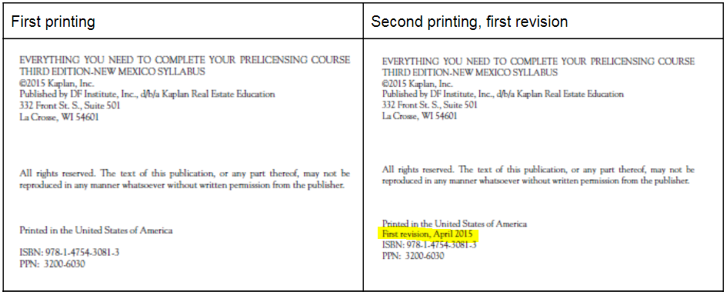
First Printing
Page/Location | Reads Now | Should Be
121/First full paragraph | To be considered the of a sale | To be considered the procuring cause of a sale
252/Item 4 | The law providing that a loan applicant who is rejected must be provided with a statement of the reasons for the rejection within 30 days is | One of the federal laws requiring disclosure to a loan applicant who is rejected for a loan on the basis of a credit report is
302/First paragraph under Appraising/ last line | it is a breach of ethics and accepted practice to collect a commission for an appraisal based on the value of the property appraised. | it is a breach of accepted practice and ethics to collect a commission for an appraisal based on the value of the property appraised.
325/Item 4, Choice B | market price | market value
527/Insert after item 15 |  | 16. C The answer is intestate. A person who dies testate leaves a valid will; one who dies intestate does not. A person who makes a last will and testament is a testator. A devisee is one who receives a gift of real estate (a devise) through a will. A legatee is one who receives a gift of personal property (legacy) through a will. (93)
527/Item 16 | 16. | 17.
527/Item 17 | 17. | 18.
527/Item 18 | 18. | 19.
527/Item 19 | 19. | 20.
535/ Item 4 | C The answer is the Fair Credit Reporting Act. If a loan application is rejected, the federal Fair Credit Reporting Act (FCRA) requires that the lender detail the reasons for the rejection in a statement that must be provided to the loan applicant within 30 days. The loan applicant also has the right to a free copy of any credit report that was considered in the loan application process. Additional state protections may also apply. (248) | C The answer is the Fair Credit Reporting Act If a loan application is rejected after consideration of a credit report, the federal Fair Credit Reporting Act (FCRA) specifies the information that the lender must provide to the loan applicant. The loan applicant has the right to a free copy of any credit report that was considered in the loan application process. Additional state protections may also apply. (248)
545/Item 4 | A (221) | C (221)
545/Item 5 | C (444) | A (444)

Second Printing, First Revision
Page/Location | Reads Now | Should Be
24/4th paragraph | Investment The capital and labor used … | The capital and labor used…
243 Assumption rules | VA-guaranteed loans made on or after March 1, 1988, are no longer assumable. | VA-guaranteed loans made on or after March 1, 1988, are no longer assumable without prior consent from the lender.
321, caption Figure 16.6 | comparables 1 and 3 show extremes | comparables 2 and 3 show extremes
431, How do I convert one kind … | Square feet x 144 = square inches | REMOVED DIVISION SIGN

Third Printing, Second Revision
Page/Location | Reads Now | Should Be
22, 2nd full paragraph | “The laws vary among the states, but all are closely linked to climactic and topographical conditions.” | “The laws vary among the states, but all are closely linked to climatic and topographical conditions.”
546, Item 74 | B | A

