Errata

At Dearborn™ Real Estate Education, we are proud of our reputation for providing the most complete, current, and accurate information in all our products. We are committed to ensuring the kind of quality you rely on. Please note the following changes, which will be reflected in the next printing of Real Estate Finance Today, Sixth Edition.

To use this document, you will need to know which revision of the book you have. The revision is indicated on the copyright page, which is on the second page of the book.

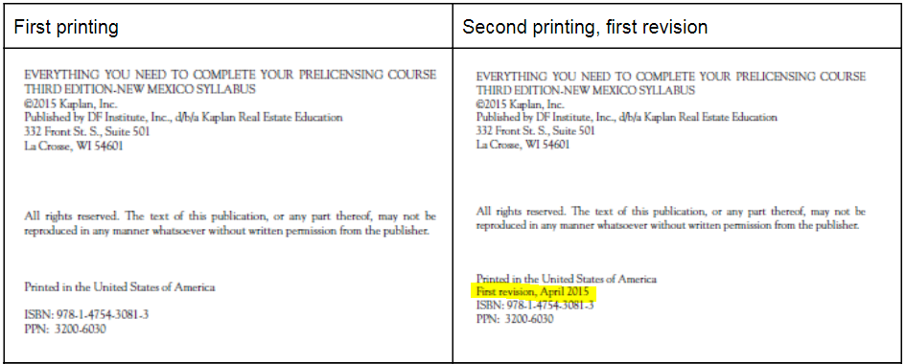

Page/Location | Reads Now | Should Be
p. 32 | The maximum loan amount that can be borrowed is set each year according to a formula based on average house prices as recorded by the Federal Housing Finance Board. | The maximum loan amount that can be borrowed is set each year according to a formula based on average house prices as recorded by the Federal Housing Finance Agency.
p. 47, Question #10 | With a gross monthly income of $8,000 with no debt, 33/38 ratios, and 25% tax and insurance allowance, and interest rate of 6.50%, Michael and Suzanne would be able to borrow approximately | With a gross monthly income of $8,000 with no debt, 33/38 ratios, and 25% tax and insurance allowance, and interest rate of 6.50%, Michael and Suzanne would be able to borrow approximately
p. 58, Case Study #1 | …payment for the same sales price of $142,000 and loan amount of $137,030 on an FHA loan. | …payment for the same sales price of $142,000 and loan amount of $137,030 on an FHA loan at 7.5%
p. 84, Unit Four Case Study Answers | Joe and Susan Brown: $55,000 income, $300 debt, $8,000 cash…  11. Cash available for down payment $8,000  12. Add line (11) to line (10) $145,630  Sales price of $142,000, 5% down payment…  Taxes and insurance ($2,600 + $350 ÷ 12) $245.83  Total Estimated Monthly Payment $1,320.38 | Joe and Susan Brown: $55,000 income, $300 debt, $5,000 cash…  11. Cash available for down payment $5,000  12. Add line (11) to line (10) $142,630  Sales price of $142,000, 3% down payment…  Taxes and insurance ($2,840 + $350 ÷ 12) $236.67  Total Estimated Monthly Payment $1,311.22
p. 87, Unit Five Case Study Answers, Case Study #1 | Taxes and insurance: ($2,600 + $350 ÷ 12) $245.83 | Taxes and insurance: (2% of Sales Price ÷ 12) $236.67

