Errata

At Dearborn™ Real Estate Education, we are proud of our reputation for providing the most complete, current, and accurate information in all our products. We are committed to ensuring the kind of quality you rely on. Please note the following changes, which will be reflected in the next printing of Real Estate Finance Today, Seventh Edition.

To use this document, you will need to know which revision of the book you have. The revision is indicated on the copyright page, which is on the second page of the book.

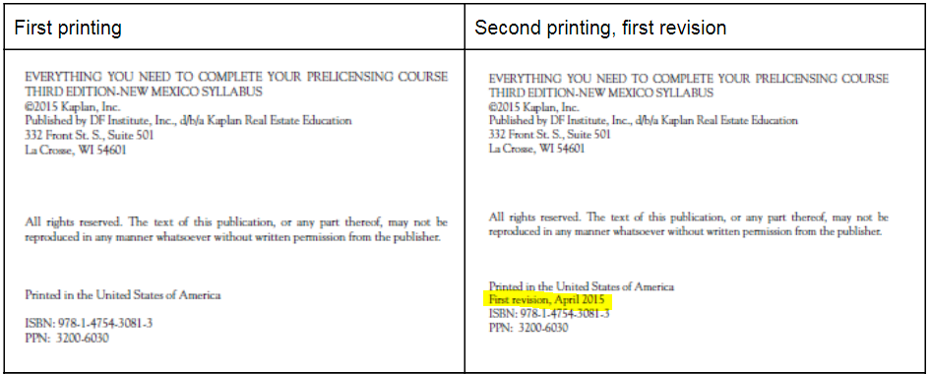

Page/Location | Reads Now | Should Be
Page 23 – FORECLOSURE RATES REACH NEW LEVELS | As of January 2016, the five states with the highest rates of foreclosures were Maryland, New Jersey, Nevada, Delaware, and Illinois. | As of January 2019, the five states with the highest rates of foreclosures were Maryland, New Jersey, Nevada, Delaware, and Illinois.
Page 27 – 2nd paragraph | The HARP refinancing program was extended through December 2018. | The HARP refinancing program was then extended again, but ended December 31, 2018.
Page 34 – Maximum Loan Amount section | Loans originated on or after October 1, 2011, use the permanent high-cost area loan limits established by FHFA under a formula of 115% of the annual median home price, up to a maximum of $679,650 for one unit property in the continental United States | Loans originated on or after October 1, 2011, use the permanent high-cost area loan limits established by FHFA under a formula of 115% of the annual median home price.
Page 35 – PMI Payment | With a minimum of 5% down, the annual renewal premium ranges from 0.75% to 1.25% of the loan amount. | With a minimum of 5% down, the annual renewal premium ranges from 0.8% to 1.25% of the loan amount.
Page 38 – Refinance or Loan Modification Programs | The Home Affordable Refinance Program (HARP) has been extended to December 31, 2018. | The Home Affordable Refinance Program (HARP) ended December 31, 2018.
Page 50 – Unit 4 Exam, question #10 | With a gross monthly income of $8,000 with no  debt, 33/38 ratios, and 25% tax and insurance  allowance, Michael and Suzanne would be able to  borrow approximately | With a gross monthly income of $8,000 with no  debt, 33/38 ratios, and 25% tax and insurance  allowance, and an interest rate of 6.50% Michael and Suzanne would be able to  borrow approximately
Page 58 – Certificate of Eligibility | Entitlement effective as of January 2005 is calculated as 25% of the current Fannie Mae and Freddie Mac conforming loan limit. (CY2018 of $453,100 × 25% = $113,275.) | Entitlement effective as of January 2005 is calculated as 25% of the current Fannie Mae and Freddie Mac conforming loan limit. (CY2019 of $484,350 × 25% = $121,087.)
Page 58 – Maximum Loan Amount | With the 2018 eligibility of $113,275, the maximum loan amount is $453,100. VA has now introduced a jumbo loan for high-cost counties where a veteran’s down payment is still zero. The VA will guarantee up to 25% of the high-cost county limit. In some cases, this amount is as much as $679,650. | With the 2019 eligibility of $121,087, the maximum loan amount is $484,350. VA has now introduced a jumbo loan for high-cost counties where a veteran’s down payment is still zero. The VA will guarantee up to 25% of the high-cost county limit. In some cases, this amount is as much as $726,525.
Page 61 – Case Study: Case #1 | Now calculate the payment for the same sales price of $142,000 and loan amount of $137,030 on an FHA loan. | Now calculate the payment for the same sales price of $142,000 and loan amount of $137,030 on an FHA loan at 7.5.
Page 71 – Appendix A chart Maximum Loan Limits – Fannie Mae and Freddie Mac Conforming Loan Limits | Fannie Mae and Freddie Mac Conforming Loan Limits (2018) | Fannie Mae and Freddie Mac Conforming Loan Limits (2019)
Page 71 – Appendix A chart Maximum Loan Limits– Fannie Mae and Freddie Mac Conforming Loan Limits | One-family unit [Standard] $453,100 [High-Cost Area] $679,650 | One-family unit [Standard] $484,350 [High-Cost Area] $726,525
Page 71 – Appendix A chart Maximum Loan Limits– Fannie Mae and Freddie Mac Conforming Loan Limits | Two-family unit [Standard] $580,150 [High-Cost Area] $870,225 | Two-family unit [Standard] $620,200 [High-Cost Area] $930,300
Page 71 – Appendix A chart Maximum Loan Limits– Fannie Mae and Freddie Mac Conforming Loan Limits | Three-family unit [Standard] $701,250 [High-Cost Area] $1,051,875 | Three-family unit [Standard] $749,650 [High-Cost Area] $1,124,475
Page 71 – Appendix A chart Maximum Loan Limits– Fannie Mae and Freddie Mac Conforming Loan Limits | Four-family unit [Standard] $871,450 [High-Cost Area] $1,307,175 | Four-family unit [Standard] $931,600 [High-Cost Area] $1,397,400
Page 71 – Appendix A chart Maximum Loan Limits – Fannie Mae and Freddie Mac Conforming Loan Limits | Maximum loan limits are 150% higher in Alaska, Hawaii, and the U.S. Virgin Islands. | Remove
Page 71 – Appendix A chart Maximum Loan Limits – FHA Forward Maximum Loan Limits | FHA Forward Maximum Loan Limits (2018) | FHA Forward Maximum Loan Limits (2019)
Page 71 – Appendix A chart Maximum Loan Limits – FHA Forward Maximum Loan Limits | One-family unit [Standard] $294,515 [High-Cost Area] $679,650 | One-family unit [Standard] $314,827 [High-Cost Area] $726,525
Page 71 – Appendix A chart Maximum Loan Limits – FHA Forward Maximum Loan Limits | Two-family unit [Standard] $377,075 [High-Cost Area] $870,225 | Two-family unit [Standard] $403,125 [High-Cost Area] $930,300
Page 71 – Appendix A chart Maximum Loan Limits – FHA Forward Maximum Loan Limits | Three-family unit [Standard] $455,800 [High-Cost Area] $1,051,875 | Three-family unit [Standard] $487,250 [High-Cost Area] $1,124,475
Page 71 – Appendix A chart Maximum Loan Limits – FHA Forward Maximum Loan Limits | Four-family unit [Standard] $566,425 [High-Cost Area] $1,307,175 | Four-family unit [Standard] $605,525 [High-Cost Area] $1,397,400
Page 71 – Appendix A – VA Maximum Loan Limit | VA Maximum Loan Limit (2018) | VA Maximum Loan Limit (2019)
Page 71 – Appendix A - COMPARISON CHART AS OF 2018 | COMPARISON CHART AS OF 2018 | COMPARISON CHART AS OF 2019
Page 71 – Appendix A – LOAN COMPARISON CHART AS OF 2019 – Maximum loan amount row | [Standard Conforming] $453,100 | $484,350
Page 71 – Appendix A – LOAN COMPARISON CHART AS OF 2019 – Maximum loan amount row | [HomeReady™] $453,100 | $484,350
Page 71 – Appendix A – LOAN COMPARISON CHART AS OF 2019 – Maximum loan amount row | [VA] | $484,350
Page 85 – Unit 5 Exam - #8 | B The answer is Alice, who served six years in the Army  Reserves. The funding fee is higher for reservists and  the National Guard. For example, in 2016—with  no money down—John and Michael would be  charged 2.15%, Alice would be charged 2.40%, and  George would pay nothing because he suffers from a  service-related disability. | B The answer is Alice, who served six years in the Army  Reserves. The funding fee is higher for reservists and  the National Guard.
Page 85 – Unit 5 Exam - #10 | A The answer is $296,235. The funding fee is 2.15%  of the loan amount; added to the loan, Martin will  borrow $296,235. ($290,000 × 2.15% = $6,235  + $290,000 = $296,235.) The new total easily  remains within the loan limit established under the  FHFA ($417,000 in 2016). At a 5% interest rate  (rate factor of 5.37), the monthly payment will be  approximately $1,590.78. | A The answer is $296,235. The funding fee is 2.15%  of the loan amount; added to the loan, Martin will  borrow $296,235. ($290,000 × 2.15% = $6,235  + $290,000 = $296,235.) The new total easily  remains within the loan limit established under the  FHFA. At a 5% interest rate  (rate factor of 5.37), the monthly payment will be  approximately $1,590.78.
Page 87 – Unit Four Case Study Answers – Case Study #1 | Joe and Susan Brown: $55,000 income, $300 debt, $8,000 cash, 7.5% interest, 30-year loan | Joe and Susan Brown: $55,000 income, $300 debt, $5,000 cash, 7.5% interest, 30-year loan
Page 87 - Unit Four Case Study Answers – Case Study #1 - Calculate monthly mortgage payment: | Sales price of $142,000, 5% down payment, $134,900 mortgage, $300 debts, 7.5% interest, 30-year loan, $2,600  annual taxes, $350 insurance, $125 per quarter HOA fee | Sales price of $142,000, 3% down payment, $134,900 mortgage, $300 debts, 7.5% interest, 30-year loan, $2,600  annual taxes, $350 insurance, $125 per quarter HOA fee
Page 87 - Unit Four Case Study Answers – Case Study #1 – Calculate monthly mortgage payment: | Taxes and insurance: ($2,840 + $350 $÷$ 12) 265.83 | Taxes and insurance: ($2,600 + $350 $÷$ 12) 245.83
Page 87 - Unit Four Case Study Answers – Case Study #1 – Calculate monthly mortgage payment: | Total Estimated Monthly Payment $1,340.38 | Total Estimated Monthly Payment $1,320.38

