Errata

At Dearborn™ Real Estate Education, we are proud of our reputation for providing the most complete, current, and accurate information in all our products. We are committed to ensuring the kind of quality you rely on. Please note the following changes, which will be reflected in the next printing of Texas Real Estate Exam Prep, Second Edition.

To use this document, you will need to know which revision of the book you have. The revision is indicated on the copyright page, which is on the second page of the book.

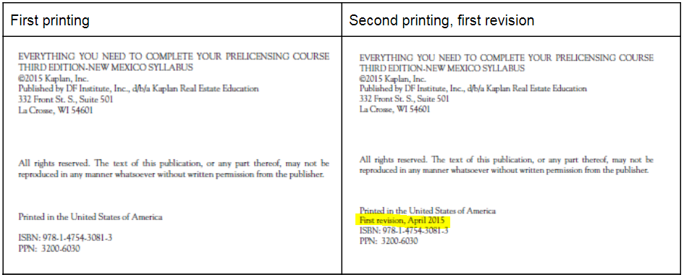

Page/Location | Reads Now | Should Be
18, question 18 | Which of the following may complete a real estate transaction or complete certain real estate activities without a license? | Which of the following may NOT complete a real estate transaction or complete certain real estate activities without a license?
29, question 14. | Sales agents are not permitted to have a trust account. | Sales agents are permitted to have a trust account.
75, question 14. | c The answer is the broker must retain all account records for four years. Sales agents are permitted to have a trust account. | Sales agents are permitted to have a trust account.
81, question 31. | b The answer is prevent fraud by someone seeking the enforcement of a contract that was never made. The purpose of the statute of frauds is not to prevent fraud by someone seeking the enforcement of a valid oral contract. | a The answer is prevent fraud by someone seeking the enforcement of a valid oral contract. The purpose of the statute of frauds is not to prevent fraud by someone seeking the enforcement of a valid oral contract.

